**Data Management System for a University**

**[**Case Study**]**

**Fares Youssef Ahmed Abd-Elaziz**

**INFORMATION TECHNOLOGICAL INSTITUTE (ITI) | DATA Integration and visualization TRACK**

* **Entity Relation Diagram**

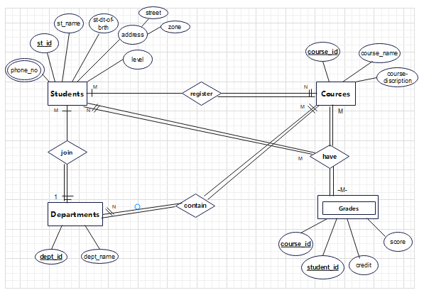

* **Mapping**

|  |  |  |  |  |  |  |  |
| --- | --- | --- | --- | --- | --- | --- | --- |
| **Student_id** | Student_name | Student_BOD | Street | zone | Level-mgr | Student_level | **Department_id** |

**Students-dept:** -

**Phone-no:**

|  |  |
| --- | --- |
| **Student_id** | Phone_no |

**Departments: -**

|  |  |
| --- | --- |
| **Department_id** | Department_name |

**Courses: -**

|  |  |
| --- | --- |
| **Course_id** | course_name |

**Grades: -**

|  |  |  |  |
| --- | --- | --- | --- |
| **Student_id** | **Course_id** | Credit | score |

**Register: -**

|  |  |
| --- | --- |
| **Student_id** | **Course_id** |

**Contain: -**

|  |  |
| --- | --- |
| **Course_id** | **Department_id** |

**Have: -**

|  |  |
| --- | --- |
| **Student_id** | **Course_id** |

* Normalization: - 1NF

**Students: -**

|  |  |  |  |  |  |  |  |
| --- | --- | --- | --- | --- | --- | --- | --- |
| **Student_id** | Student_name | Student_BOD | Street | zone | Level-mgr | Student_level | **Department_id** |

**Phone-no: -**

|  |  |
| --- | --- |
| **Student_id** | **Phone_no** |

**Departments: -**

|  |  |
| --- | --- |
| **Department_id** | Department_name |

**Courses: -**

|  |  |
| --- | --- |
| **Course_id** | course_name |

**Grades: -**

|  |  |  |
| --- | --- | --- |
| **Course_id** | Credit | score |

**Register: -**

|  |  |
| --- | --- |
| **Student_id** | **Course_id** |

**Contain: -**

|  |  |
| --- | --- |
| **Course_id** | **Department_id** |

**Have: -**

|  |  |
| --- | --- |
| **Student_id** | **Course_id** |

* **Normalization: - 2NF**

**Students: -**

|  |  |  |  |  |  |  |  |
| --- | --- | --- | --- | --- | --- | --- | --- |
| **Student_id** | Student_name | Student_BOD | Street | zone | Level-mgr | Student_level | **Department_id** |

**Phone-no: -**

|  |  |
| --- | --- |
| **Student_id** | **Phone_no** |

**Departments: -**

|  |  |
| --- | --- |
| **Department_id** | Department_name |

**Courses: -**

|  |  |
| --- | --- |
| **Course_id** | course_name |

**Grades: -**

|  |  |  |
| --- | --- | --- |
| **Course_id** | Credit | score |

**Register: -**

|  |  |
| --- | --- |
| **Student_id** | **Course_id** |

**Contain: -**

|  |  |
| --- | --- |
| **Course_id** | **Department_id** |

**Have:-**

|  |  |
| --- | --- |
| **Student_id** | **Course_id** |

* **Normalization: - 3NF**

**Students: -**

|  |  |  |  |  |  |
| --- | --- | --- | --- | --- | --- |
| **Student_id** | Student_name | Student_BOD | **Street no** | **Student_level** | **Department_id** |

**Phone-no: -**

|  |  |
| --- | --- |
| **Student_id** | **Phone_no** |

**Location: -**

|  |  |
| --- | --- |
| **Street no** | zone |

**Level: -**

|  |  |
| --- | --- |
| **Student-level** | Level-mgr |

**Departments: -**

|  |  |
| --- | --- |
| **Department_id** | Department_name |

**Courses: -**

|  |  |
| --- | --- |
| **Course_id** | course_name |

**Grades: -**

|  |  |  |
| --- | --- | --- |
| **Course_id** | Credit | score |

**Register: -**

|  |  |
| --- | --- |
| **Student_id** | **Course_id** |

**Contain: -**

|  |  |
| --- | --- |
| **Course_id** | **Department_id** |

**Have: -**

|  |  |
| --- | --- |
| **Student_id** | **Course_id** |

* **SQL Implementation**

**Create students Schema**

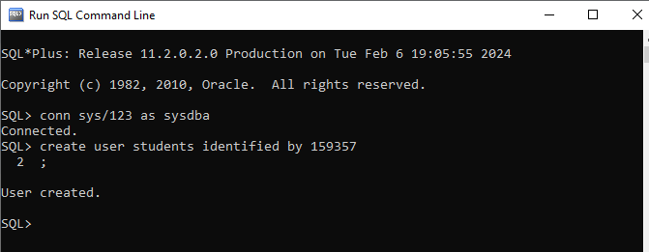

**Grant table, view, sequence, procedure, and function creation and free space for insert new data to Students.**

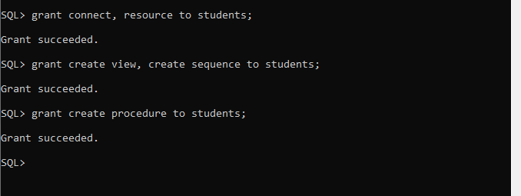

* **Tables Creation: -**

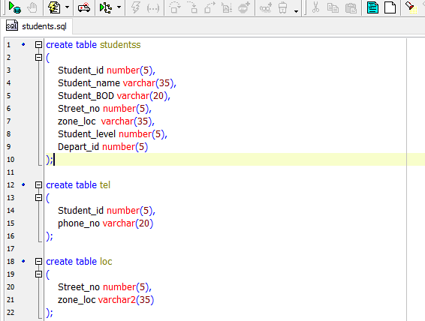

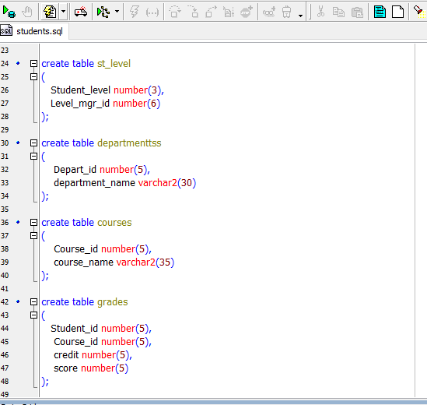

* **Test and validate the correctness of the database**

**• The valid range of grades is (0: 100)**

**• The valid range for GPA is (0:4)**

**• The valid range for credit value is (0:4)**

* **PL/SQL Implementation**
* **update courses proc**

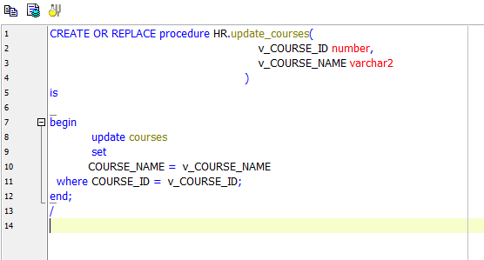

* **update department proc**

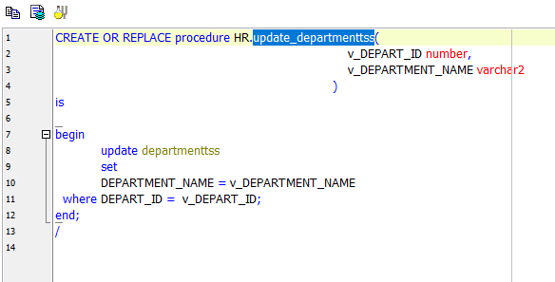

* **update grades2 proc**

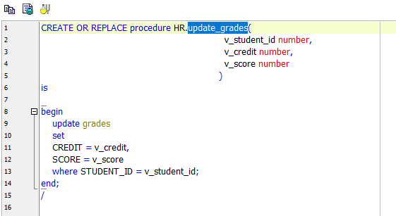

* **update loc proc**

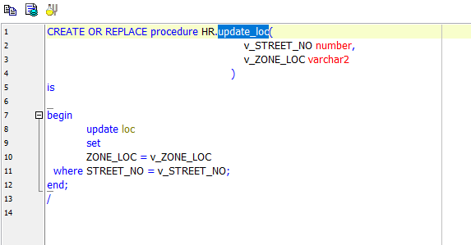

* **update st_level proc**

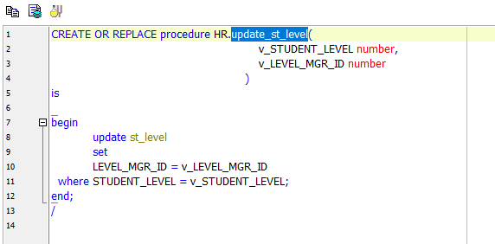

* **update tel proc**

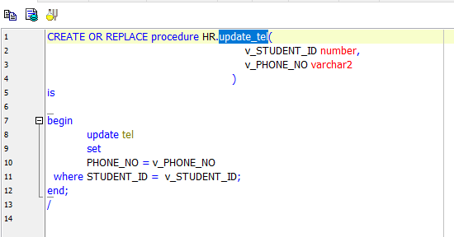

* **Calculate GPA Function**

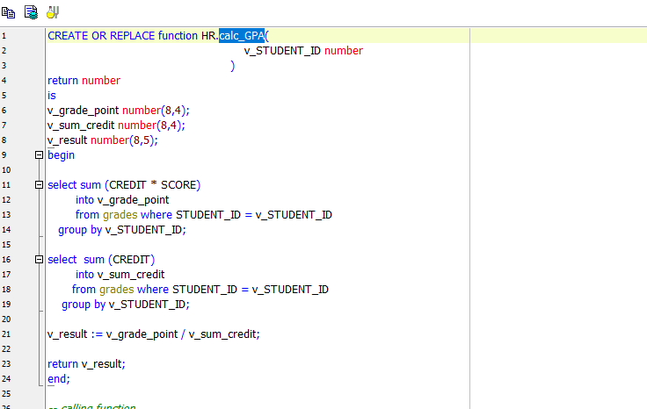

* **Bash Scripting: -**
* Bash script for database backup

**#!/bin/bash**

**SOURCE_DIR="/E/oracle/app/oracle"**

**BACKUP_DIR="/D/backup"**

**TIMESTAMP=$(date +%Y%m%d_%H%M%S)**

**tar cvf "${BACKUP_DIR}/backup_${TIMESTAMP}.tar" -C "${SOURCE_DIR}”.**

**echo "Backup completed. Archive stored in ${BACKUP_DIR}/backup_${TIMESTAMP}.tar"**

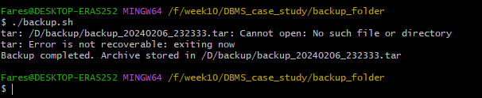

* Bash script for monitoring disk space and sending alerts.

**#!/bin/bash**

**# Set the threshold for disk usage (in percentage)**

**THRESHOLD=80**

**# Get current disk usage**

**DISK_USAGE=$(df -h | grep "C:"| awk '{ print $6 }' | tr '%' ' ')**

**#echo $DISK_USAGE**

**if [[ $DISK_USAGE -gt $THRESHOLD]]; then**

**# Send alert (replace with your notification method)**

**echo "ALERT: Disk usage exceeded $THRESHOLD% - Current usage: $DISK_USAGE%"**

**else**

**echo "Disk usage is within the threshold: $DISK_USAGE%"**

**fi**

* **Memory Usage:-**

**TotalSpace=$(systeminfo | grep 'Total Physical Memory' | awk '{ print $4 }' | tr -d ',')**

**AvailableSpace=$(systeminfo | grep 'Available Physical Memory' | awk '{ print $4 }' | tr -d ',')**

**UsedSpace=$((TotalSpace - AvailableSpace))**

**echo "Used Space = $UsedSpace MB"**

**Percentt=$(((AvailableSpace*100)/UsedSpace))**

**THRESHOLDD=60**

**if [[ $Percentt -gt $THRESHOLDD ]]; then**

**echo "ALERT !! Memory consumption has exceeded $THRESHOLDD% , Current Consumption : $Percentt%"**

**else**

**echo "Memory consumption is safe and within the threshold : $Percentt%"**

**fi**